Week-3 Spring REST using Spring Boot 3

Create a Spring Web Project using Maven
SpringLearnApplication.java:
package com.cognizant.springlearn;
import org.springframework.boot.SpringApplication;
import org.springframework.boot.autoconfigure.SpringBootApplication;
import org.slf4j.Logger;
import org.slf4j.LoggerFactory;
@SpringBootApplication
public class SpringLearnApplication {

private static final Logger LOGGER = LoggerFactory.getLogger(SpringLearnApplication.class);
public static void main(String[] args) {
SpringApplication.run(SpringLearnApplication.class, args);
LOGGER.info("Inside main method...");
}
}
OUTPUT:
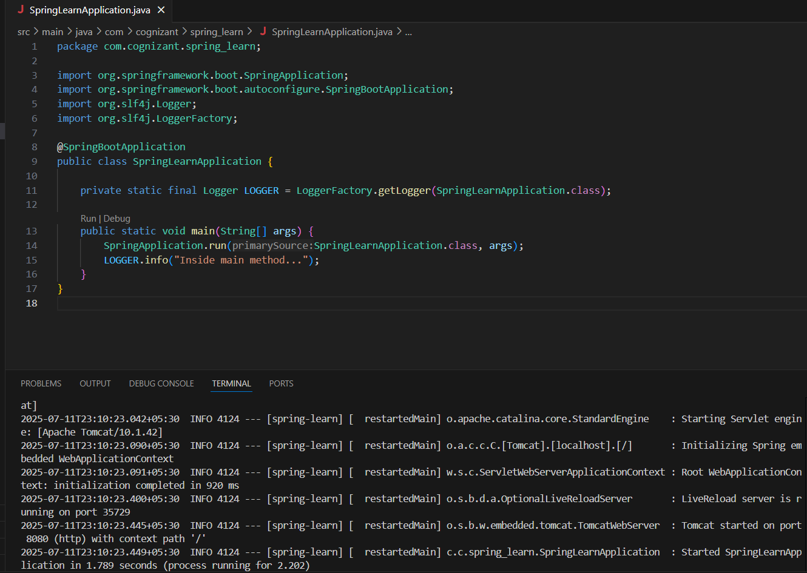
Spring Core – Load Country from Spring Configuration XML
Country.java:
package com.cognizant.springlearn;

public class Country {
private String code;
private String name;

public Country() {

}

public Country(String code, String name) {
this.code = code;
this.name = name;
}

public String getCode() {
return code;
}

public void setCode(String code) {
this.code = code;
}

public String getName() {
return name;
}

public void setName(String name) {
this.name = name;
}

@Override
public String toString() {
return "Country [code=" + code + ", name=" + name + "]";
}
}

SpringLearnApplication.java (Main class):
package com.cognizant.spring_learn;

import java.util.*;

public class SpringLearnApplication {

public static void main(String[] args) {
System.out.println("START");
List<Country> countryList = new ArrayList<>();

countryList.add(new Country("IN", "India"));
countryList.add(new Country("US", "United States"));
countryList.add(new Country("CN", "China"));
countryList.add(new Country("JP", "Japan"));
countryList.add(new Country("DE", "Germany"));
countryList.add(new Country("FR", "France"));
countryList.add(new Country("BR", "Brazil"));
countryList.add(new Country("ZA", "South Africa"));
countryList.add(new Country("AU", "Australia"));
countryList.add(new Country("RU", "Russia"));

for (Country country : countryList) {
System.out.println(country);
}

System.out.println("END");
}
}

OUTPUT:
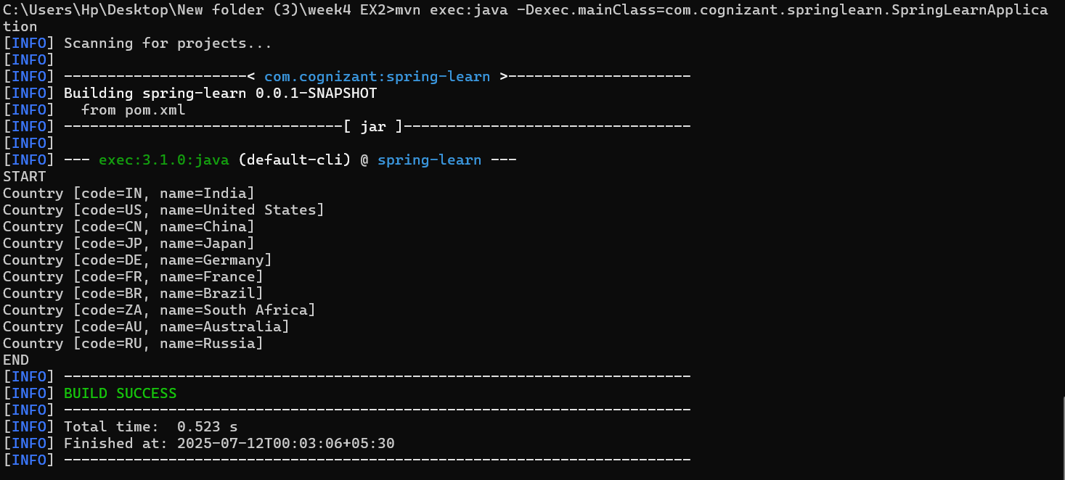

================================================================
Hello World RESTful Web Service
HelloController.java:
package com.cognizant.springlearn.controller;
import org.slf4j.Logger;
import org.slf4j.LoggerFactory;
import org.springframework.web.bind.annotation.*;

@RestController
public class HelloController {

private static final Logger LOGGER = LoggerFactory.getLogger(HelloController.class);

@GetMapping("/hello")
public String sayHello() {
LOGGER.info("START");
String message = "Hello World!!";
LOGGER.info("END");
return message;
}
}
SpringLearnApplication.java:
package com.cognizant.springlearn;
import org.springframework.boot.SpringApplication;
import org.springframework.boot.autoconfigure.SpringBootApplication;

@SpringBootApplication
public class SpringLearnApplication {
public static void main(String[] args) {
SpringApplication.run(SpringLearnApplication.class, args);
}
}
OUTPUT: http://localhost:8083/hello
Browser:
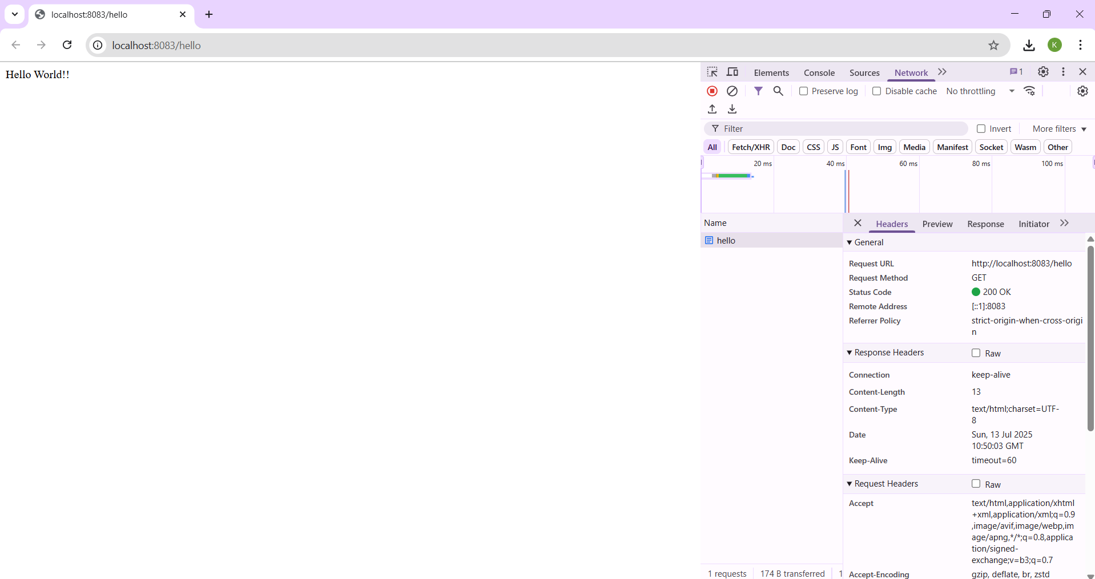

Postman:
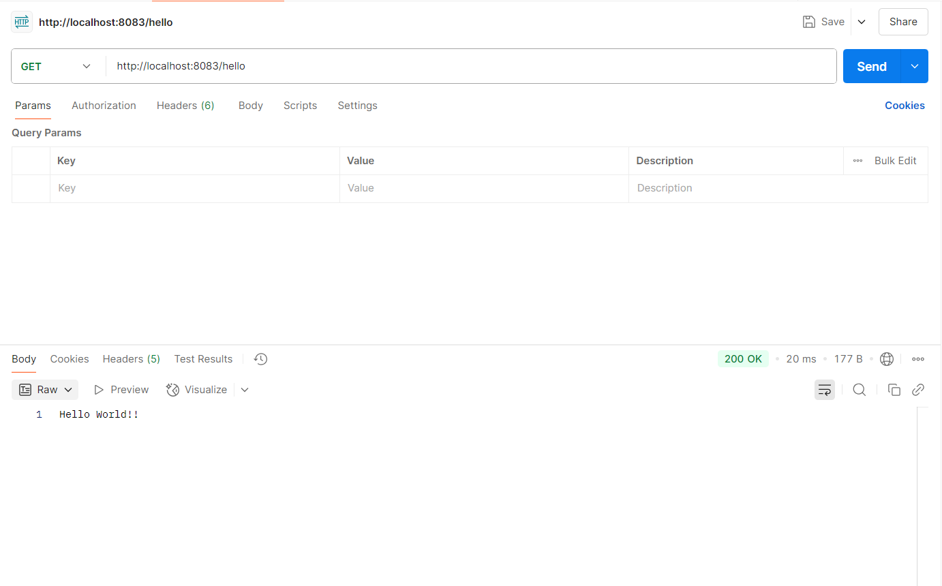
================================================================
REST - Country Web Service
CountryController.java:
package com.cognizant.springlearn.controller;

import com.cognizant.springlearn.model.Country;
import org.springframework.context.ApplicationContext;
import org.springframework.context.support.ClassPathXmlApplicationContext;
import org.springframework.web.bind.annotation.RequestMapping;
import org.springframework.web.bind.annotation.RestController;

@RestController
public class CountryController {

@RequestMapping("/country")
public Country getCountryIndia() {
ApplicationContext context = new ClassPathXmlApplicationContext("country.xml");
Country country = (Country) context.getBean("in");
return country;
}
}
OUTPUT: http://localhost:8083/countries
Browser:
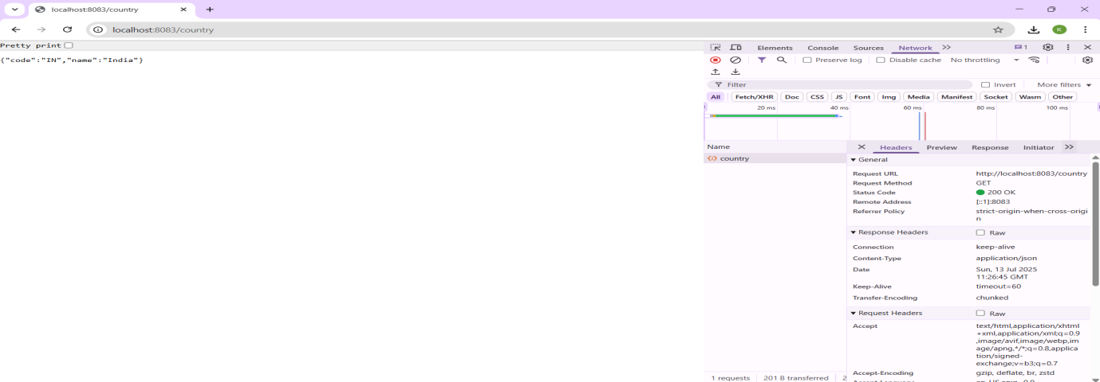

Postman:
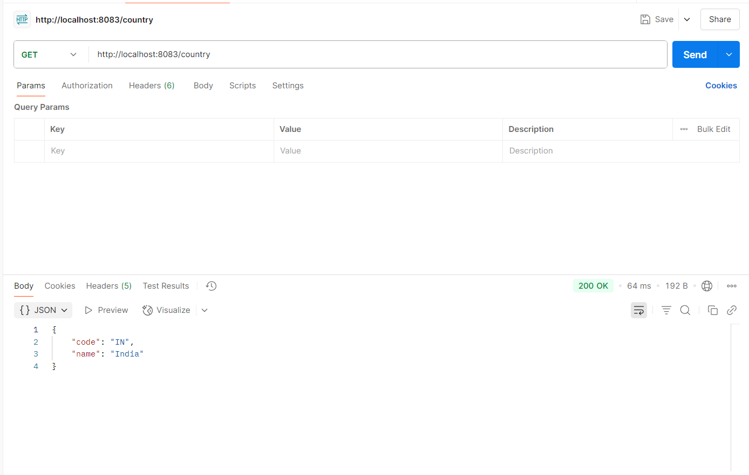
================================================================

REST - Get country based on country code
CountryController.java:
package com.cognizant.springlearn.controller;
import com.cognizant.springlearn.model.Country;
import com.cognizant.springlearn.service.CountryService;
import org.springframework.beans.factory.annotation.Autowired;
import org.springframework.web.bind.annotation.*;

@RestController
public class CountryController {

@Autowired
private CountryService countryService;

@GetMapping("/countries/{code}")
public Country getCountry(@PathVariable String code) throws Exception {
return countryService.getCountry(code);
}
}

CountryService.java:
package com.cognizant.springlearn.service;

import com.cognizant.springlearn.model.Country;
import org.springframework.beans.factory.annotation.Autowired;
import org.springframework.context.ApplicationContext;
import org.springframework.stereotype.Service;

import java.util.List;

@Service
public class CountryService {

@Autowired
private ApplicationContext context;

public Country getCountry(String code) throws Exception {
List<Country> countryList = (List<Country>) context.getBean("countryList");

return countryList.stream()
.filter(c -> c.getCode().equalsIgnoreCase(code))
.findFirst()
.orElseThrow(() -> new Exception("Country not found for code: " + code));
}
}

Country.java:
package com.cognizant.springlearn.model;

public class Country {

private String code;
private String name;

public String getCode() {
return code;
}

public void setCode(String code) {
this.code = code;
}

public String getName() {
return name;
}

public void setName(String name) {
this.name = name;
}
}

OUTPUT: http://localhost:8083/countries/in
Browser:
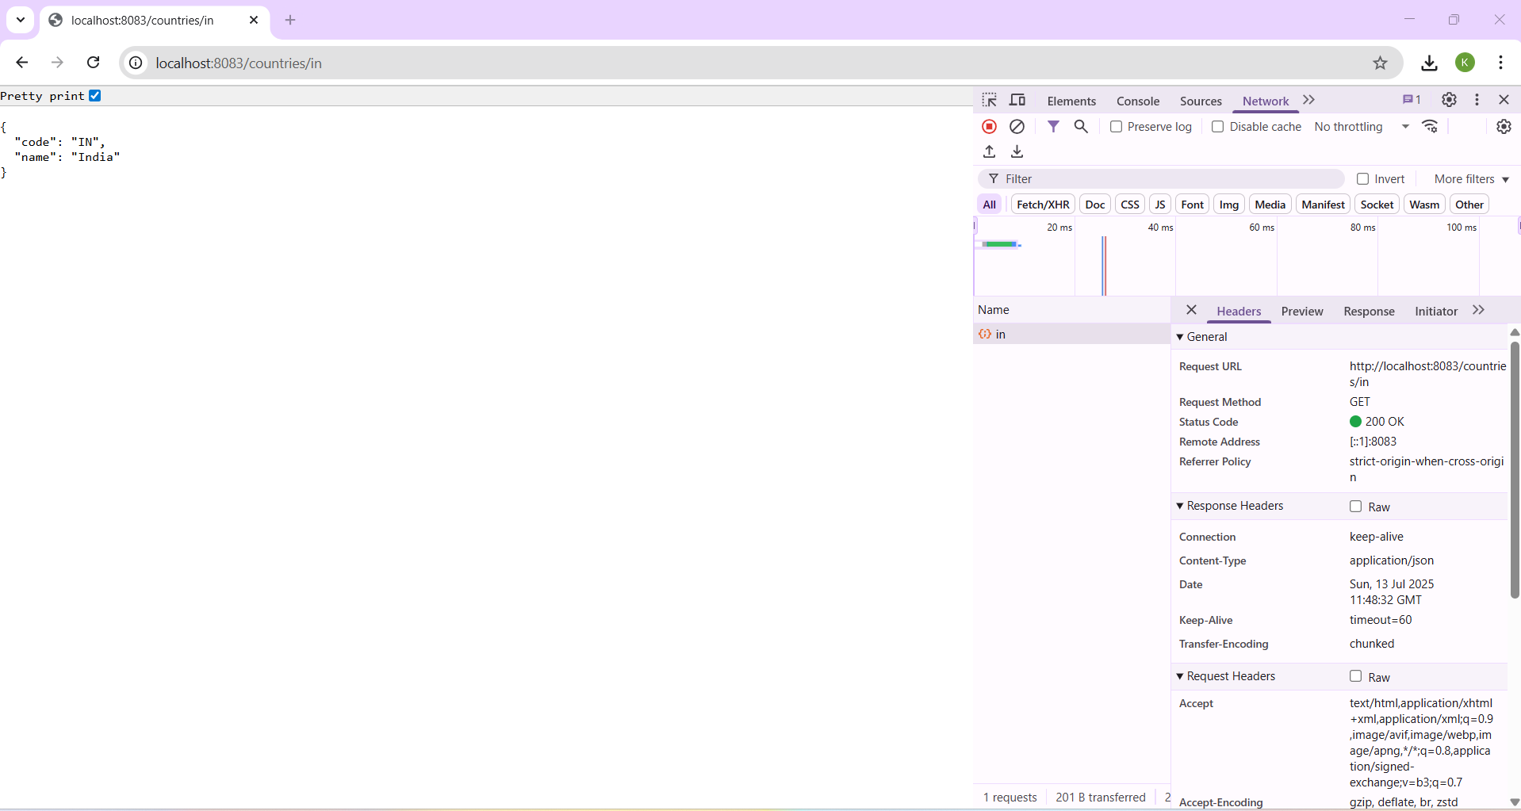

Postman:
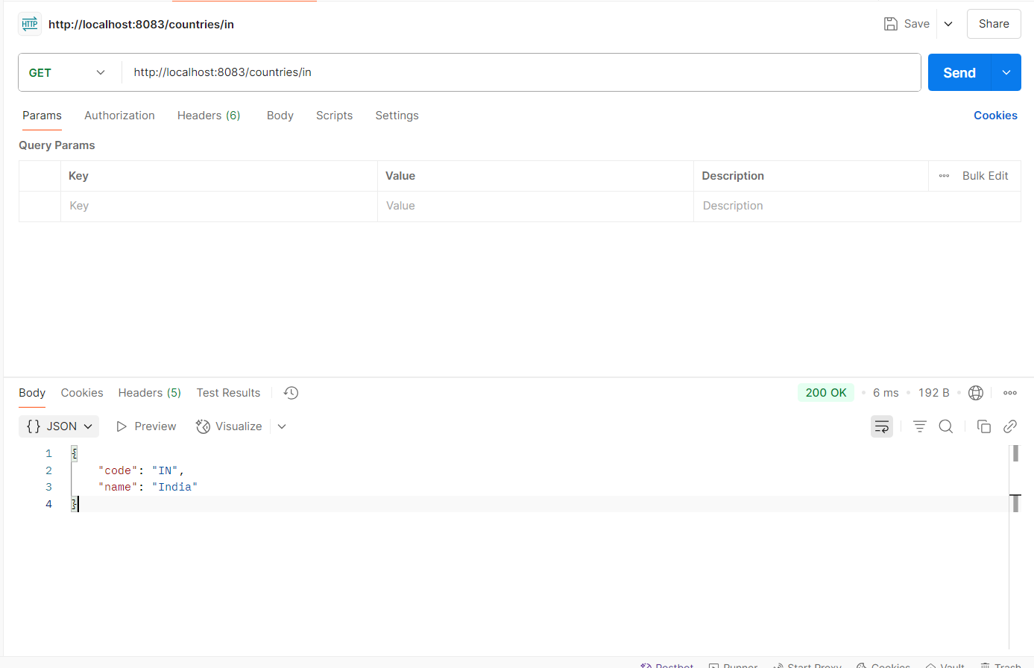
================================================================

Create authentication service that returns JWT
AuthenticationController.java:
package com.cognizant.springlearn.controller;

import com.cognizant.springlearn.util.JwtUtil;
import org.springframework.beans.factory.annotation.Autowired;
import org.springframework.http.ResponseEntity;
import org.springframework.web.bind.annotation.*;

import java.util.Base64;

@RestController
public class AuthenticationController {

@Autowired
private JwtUtil jwtUtil;

@GetMapping("/authenticate")
public ResponseEntity<?> authenticate(@RequestHeader(value = "Authorization", required = false) String authHeader) {
System.out.println("Incoming request to /authenticate");

if (authHeader == null || !authHeader.startsWith("Basic ")) {
return ResponseEntity.status(401).body("Missing or invalid Authorization header");
}

try {
String base64Credentials = authHeader.substring("Basic ".length()).trim();
byte[] decodedBytes = Base64.getDecoder().decode(base64Credentials);
String credentials = new String(decodedBytes);
String[] parts = credentials.split(":", 2);

if (parts.length != 2) {
return ResponseEntity.status(401).body("Invalid Authorization format");
}

String username = parts[0];
String password = parts[1];

if (!"user".equals(username) || !"pwd".equals(password)) {
return ResponseEntity.status(401).body("Invalid username or password");
}

String token = jwtUtil.generateToken(username);
return ResponseEntity.ok().body("{\"token\":\"" + token + "\"}");

} catch (Exception e) {
return ResponseEntity.status(500).body("Internal server error: " + e.getMessage());
}
}
}

JwtUtil.java:
package com.cognizant.springlearn.util;

import io.jsonwebtoken.Jwts;
import io.jsonwebtoken.SignatureAlgorithm;
import org.springframework.stereotype.Component;
import java.util.Date;

@Component
public class JwtUtil {
private final String SECRET_KEY = "secret";

public String generateToken(String username) {
return Jwts.builder()
.setSubject(username)
.setIssuedAt(new Date())
.setExpiration(new Date(System.currentTimeMillis() + 3600000))
.signWith(SignatureAlgorithm.HS256, SECRET_KEY)
.compact();
}
}

SecurityConfig.java:
package com.cognizant.springlearn.security;
import org.springframework.context.annotation.Configuration;
import org.springframework.security.config.annotation.web.builders.HttpSecurity;
import org.springframework.security.config.annotation.web.configuration.WebSecurityConfigurerAdapter;

@Configuration
public class SecurityConfig extends WebSecurityConfigurerAdapter {

@Override
protected void configure(HttpSecurity http) throws Exception {
http
.csrf().disable()
.authorizeRequests()
.antMatchers("/authenticate").permitAll()
.anyRequest().authenticated()
.and()
.httpBasic();
}
}
OUTPUT: http://localhost:8090/authenticate
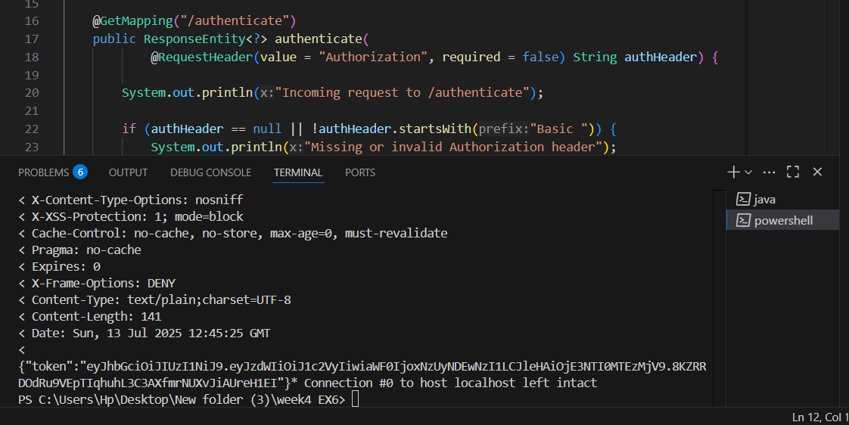
Postman:



